1. [Arrays and Pointers | C-Programming | Free Crash Course by Pankaj Sharma Sir | CS/IT | GATE 2021 - YouTube](https://www.youtube.com/watch?v=UAMMBYzVeLE) {MUSTTTTT WATCH FIRST}
2. <https://gateoverflow.in/43575/gate2003-74?show=338119#a338119>
3. [Programming: GATE CSE 2003 | Question: 73 (gateoverflow.in)](https://gateoverflow.in/960/gate-cse-2003-question-73)
4. [Programming: GATE CSE 2013 | Question: 42 (gateoverflow.in)](https://gateoverflow.in/60/gate-cse-2013-question-42)
5. [Sequence point - Wikipedia](https://en.wikipedia.org/wiki/Sequence_point)

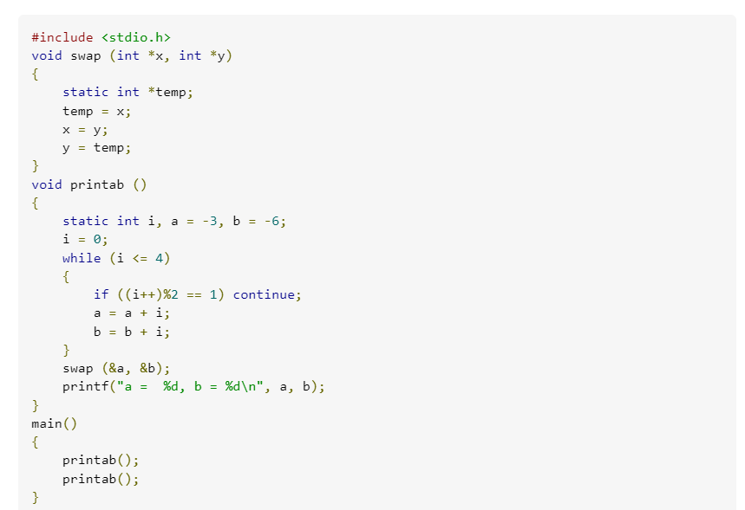

ANS: a=15, b=12

Imp comment regarding it :-

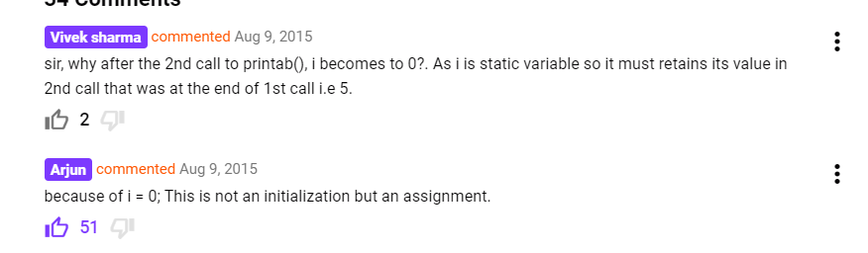

1. Memory leak, Dangling pointer and Uninitialized Pointer explained beautifully : [Pointers - GATE Question 3 - YouTube](https://www.youtube.com/watch?v=MQ27Gxz_mjc&list=PLsFENPUZBqipuTJXgm7xAOR0UnY_8OY07&index=45) [ MUST WATCH] [c - Difference between dangling pointer and memory leak - Stack Overflow](https://stackoverflow.com/questions/13132798/difference-between-dangling-pointer-and-memory-leak)
2. [(2) Understanding the Dangling Pointers - YouTube](https://www.youtube.com/watch?v=qNgV7oAHElk)
3. <https://en.wikipedia.org/wiki/Dangling_pointer#:~:text=a%20pointer%20becomes%20dangling%20when%20the%20block%20of%20memory%20it%20points%20to%20is%20freed>.
4. Segmentation Fault : [c++ - What is a segmentation fault? - Stack Overflow](https://stackoverflow.com/questions/2346806/what-is-a-segmentation-fault)
5. [Programming: MadeEasy Subject Test 2019: Programming & DS - Programming In C (gateoverflow.in)](https://gateoverflow.in/282711/madeeasy-subject-test-2019-programming-%26-ds-programming-in?show=282720#c282720)
6. 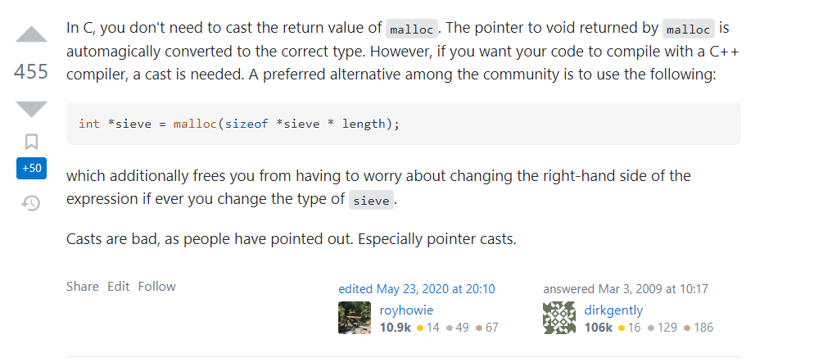[c - What is the difference between NULL, '\0' and 0? - Stack Overflow](https://stackoverflow.com/questions/1296843/what-is-the-difference-between-null-0-and-0)
7. [C Right-Left Rule (Rick Ord's CSE 131 - UC San Diego) (ucsd.edu)](https://cseweb.ucsd.edu/~ricko/CSE131/rt_lt.rule.html) - BRAHMASTRA rule to read complicated pointer statements
8. <https://gateoverflow.in/2176/gate-cse-2012-question-48?show=386635#c386635>
9. 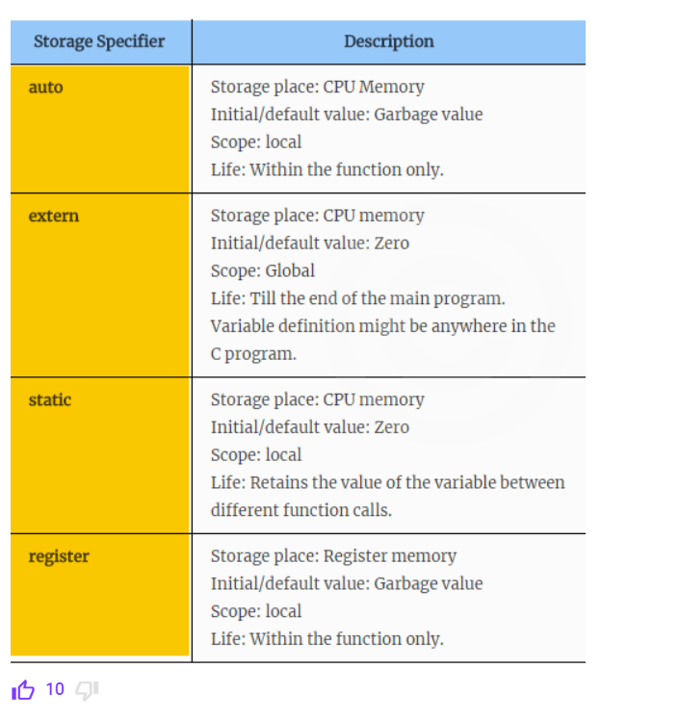
10. [c - Comparison operation on unsigned and signed integers - Stack Overflow](https://stackoverflow.com/questions/2084949/comparison-operation-on-unsigned-and-signed-integers)

When -1 is converted to unsigned int the result is the maximal possible unsigned int value (same as UINT_MAX)

Even if you treat the subtraction in an unsigned world, 1000 - (4,294,967,295) = -4,294,966,295 = 1,001 which is what you get.

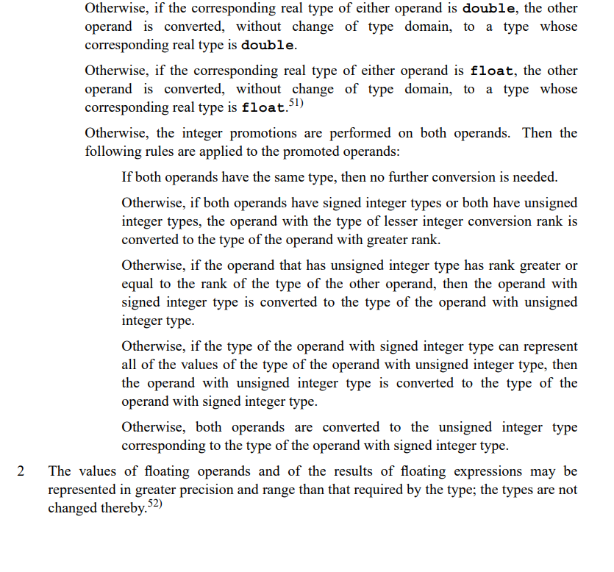

[Programming: GATE CSE 2017 Set 1 | Question: 53 (gateoverflow.in)](https://gateoverflow.in/118473/gate-cse-2017-set-1-question-53)

1. [The strlen() Function in C - C Programming Tutorial - OverIQ.com](https://overiq.com/c-programming-101/the-strlen-function-in-c/) [Must Read]

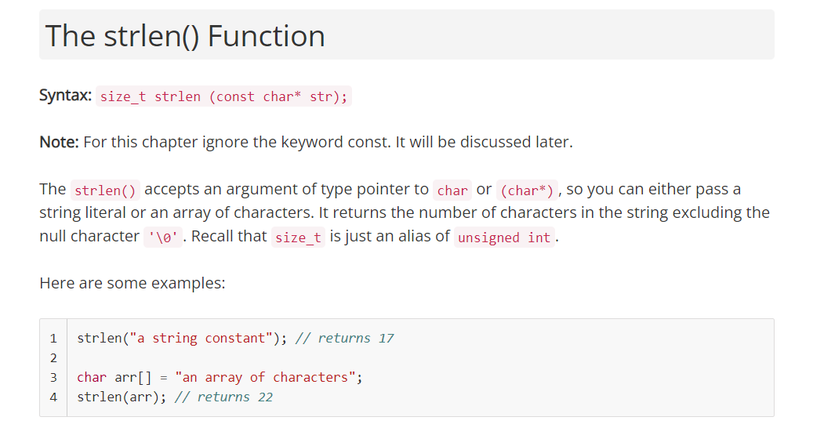

[Difference between strlen() and sizeof() for string in C - GeeksforGeeks](https://www.geeksforgeeks.org/difference-strlen-sizeof-string-c-reviewed/)

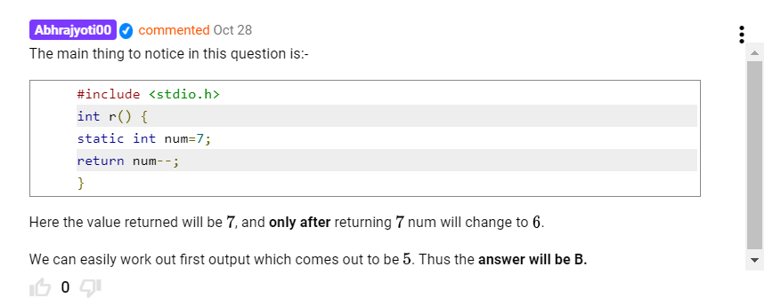

<https://gateoverflow.in/302821/gate-cse-2019-question-27?show=386691#c386691>

1. Regarding Fibonacci Recursion:-

<https://gateoverflow.in/687/gate-cse-2000-question-16?show=240808#c240808>

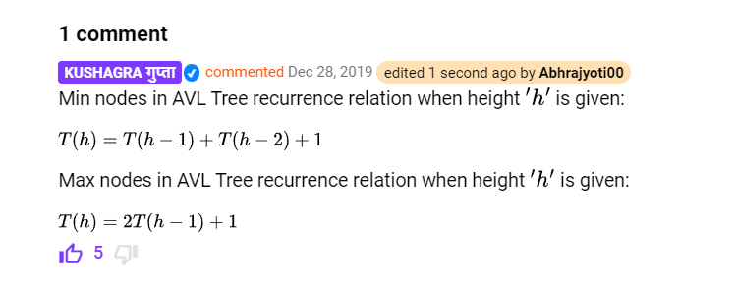

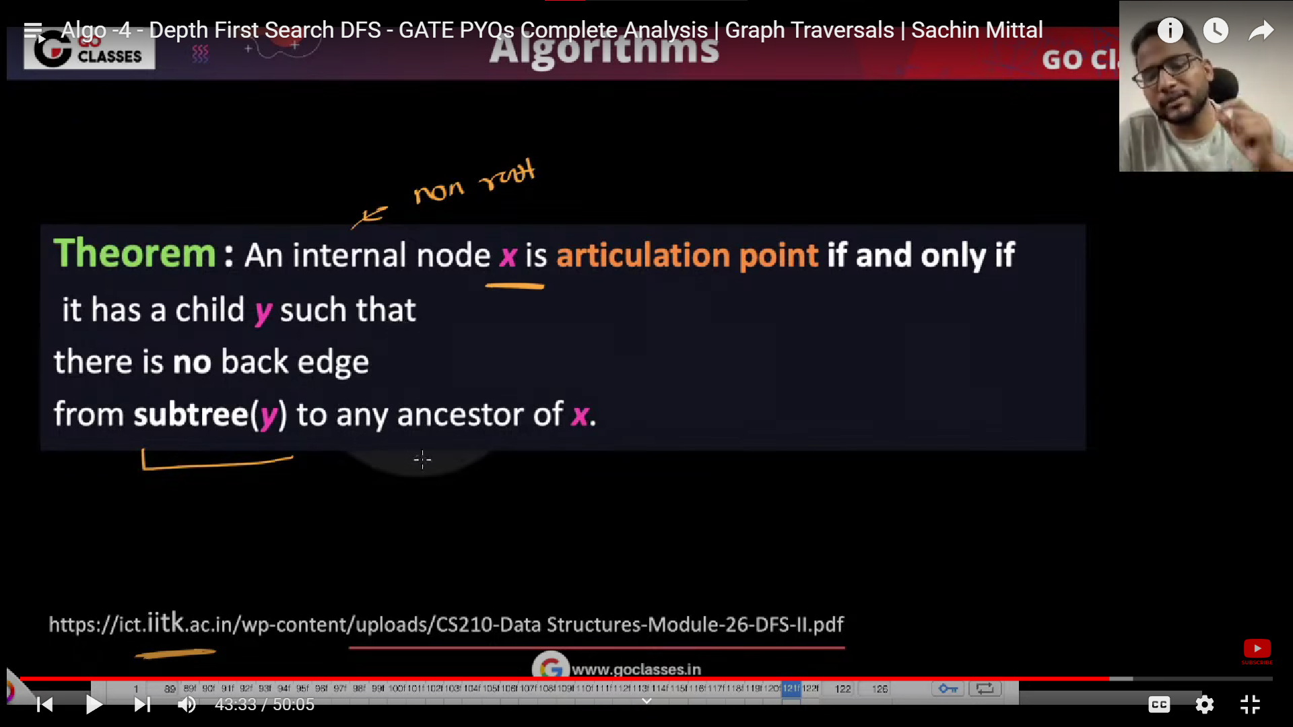

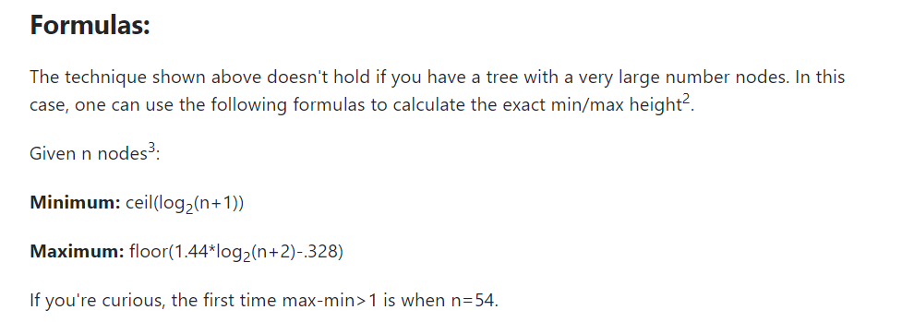

Those are the formulas for height of AVL tree